DIRECTIVE

TO: Secretary Kevin Atticks, Maryland Department of Agriculture
Secretary Serena McIlwain, Maryland Department of the Environment

CC: Lester Davis, Chief of Staff
Manny Welsh, Principal Deputy Chief of Staff & Chief Administrative Officer
Chichi Nyagah-Nash, Deputy Chief of Staff

FROM: Governor Wes Moore

RE: Directive on State Response to Impact of Late Spring Frost on Crops

DATE: May 29, 2026

______________________________________________________________________________

Agriculture is the cornerstone of Maryland’s economy, history, and culture, serving as the State’s leading commercial industry and the bedrock of our regional food security. The severe statewide freeze that occurred on April 21, 2026 has resulted in a significant crisis for Maryland’s agricultural community, and is compounded by the ongoing drought designation affecting a majority of Maryland counties.

The April freeze caused catastrophic damage to commodity and perennial crops, leading to historic losses in fruit and grape yields that will result in a multi-year recovery cycle for vines and orchards, significantly adding to the labor and maintenance costs without the benefit of 2026 harvest revenue. The concurrent drought conditions have further strained the State’s grain, forage, and livestock sectors, creating a cumulative economic burden that threatens the long-term viability of multi-generational family farms. These successive environmental challenges underscore the urgent need for a unified and coordinated response across all State and local agencies that prioritizes agricultural stability and fortifies the long-term resilience of our food system.

The evolving nature of farming in Maryland requires that the State ensure the ease of establishment and sustainability of diversified operations, allowing farmers to maintain their economic base during periods of environmental volatility.

Therefore, pursuant to my authority as the head of the executive branch of State government under Article II, Section 1 of the Maryland Constitution, as well as State Government Article §3-302, I hereby direct the following measures in response to the impact of the late spring frost on crops in Maryland:

The Department of Agriculture shall:

- Waive the 51% Maryland crop or 20-acre minimum requirement for Class 4 Limited Wineries as authorized under the Alcoholic Beverages and Cannabis Article §2–206;
- Facilitate distribution of all available federal disaster funds and programming;
- Develop an irrigation task force for agricultural producers;
- Develop a producer education and risk management task force to elevate existing Farm Service Agency and Risk Management Agency programs;
- Instruct the Maryland Agricultural and Resource-Based Industry Development Corporation to consider modifications to enhance opportunities within their programs that support farmers and watermen impacted by the natural disaster incidents; and
- Encourage all Maryland institutions, organizations, food banks, and consumers to purchase local products whenever possible to support our farms and value-added agricultural businesses.

The Department of the Environment shall:
- Prioritize and streamline applications for water appropriation permits for agricultural production.

The Governor’s Intergovernmental Commission on Agriculture shall:
- Assess how state and local regulatory agencies can better support affected agricultural sectors.

This Directive is effective as of the date indicated above, and shall remain in force until further notice.
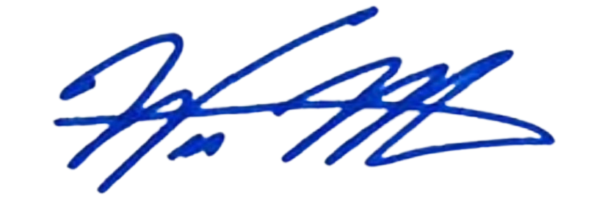

____________________________________
Wes Moore, Governor

